Software Requirements Specification Template

E-Commerce Project

Software Requirements Specification

Version 1.0

05/24/2022

Varun Reddy Pathuri
Bharath Kumar Bollena
Aparna Sundhari
Venkata Krishna Reddy Katreddy
Sai Vikram Reddy Yadavally

Submitted in partial fulfilment
Of the requirements of
CSIS 44-691 Graduate Directed Project 1

Revision History

Date | Description | Author | Comments
<date> | <Version 1> | <Your Name> | <First Revision>

Document Approval

The following Software Requirements Specification has been accepted and approved by the following:
Signature | Printed Name | Title | Date

Table of Contents

Table of Contents Page Number

- Introduction
E-commerce is quickly becoming a widely recognized and used business model. More and more businesses are creating websites that allow them to conduct commercial transactions over the internet. It is fair to state that online purchasing is growing more common.
A virtual store on the Internet where clients may explore the catalog and pick goods of interest is known as an online store. A shopping cart may be used to collect the specified products. The items in the shopping cart will be presented as an order at checkout. More information will be required at that time to complete the transaction.
  - Purpose
The goal of this project is to create a general-purpose e-commerce store where anybody may buy anything (books, CDs, computers, mobile phones, electrical devices, and home appliances) from the comfort of their own home over the Internet. However, for the sake of implementation, this study will focus on an online bookshop.
A billing address, a mailing address, a delivery choice, and payment details such as credit card number are typically required of customers. As soon as the order is placed, the customer receives an email notice.
  - Scope, Definitions, Acronyms, and Abbreviations
E-commerce development has great potential. Products may now be purchased online through sites such as Flipkart and Amazon. Everything from gym equipment to computers is available online in the age of e-commerce. E-commerce is a collection of commercial scenarios. E-trading, E-franchising, E-mailing, and E-engineering are examples. Scope of e-commerce can be enumerated as follows:
=> Exchange of digitized information
=> Technology-enabled
=> Customers retention
=> Accounting
=> Supplier integration
=> Support the exchange
  - References
1.Z. Ruvalcaba and A. Boehm, "Introduction To The Web Development" in murach's HTML5 and CSS 3 1sted., Fresno, CA:Mike Murach and Associates, Inc., pp. 4-7, 2012.
2.Model-View-Controller, 2015, [online] Available: http://en.wikipedia.org.
  - Overview
A website that allows people to buy and sell physical goods, services, and digital products over the internet rather than at a brick-and-mortar location. Through an e-commerce website, a business can process orders, accept payments, manage shipping and logistics, and provide customer service.
- General Description
  - Product Perspective
  - Product Functions
  - User Characteristics
  - General Constraints
  - Assumptions and Dependencies
- Specific Requirements
  - External Interface Requirements
HTML, CSS, React components, JavaScript
    - User Interfaces
We are designing the user interface with HTML, CSS and React
    - Hardware Interfaces
We need a laptop to run the server in the localhost and test the application. In cloud we can access the application through Heroku.
    - Software Interfaces
The software’s needed are the VSCode Editor to build the code. Node js , React js are needed to be installed in the laptop.
    - Communications Interface
In the present Industry, the different API communications are REST, RPC and SOAP. We will use the REST API calls to communicate with sever using Postman to check the output.
  - Functional Requirements
Customer side: -
• SignUp/Registering new user
• Logging in a user
• Changing a password/forgot password
• Getting product(s) Information
• Deleting product(s)
• Adding products to cart
• Editing items in cart (quantity change & deleting from cart)
• Payment conformation
• Order conformation after payment
• Feedback for a product after buying
• Order History for customer
Administration side: -
• Logging in a user
• Changing a password/forgot password
• Creating a new product
• Updating a product information
• Getting user info
  - Use Cases
This Project The primary goal of an e-commerce site is to sell goods and services online. This project deals with developing an e-commerce website for all categories. It provides the user with a catalog of different items available for purchase in the store.
  - Class/Objects
We will create the classes accordingly once we started the development.
  - Non-Functional Requirements
These needs, as previously stated, are crucial for a great user experience and optimal website performance.
3.5.1. Performance
You must pay extra attention to performance in the non-functional requirements description if you want to increase visitors to your website. Regardless of the amount of integrations or traffic on your website, the focus should be on loading the e-commerce shop as quickly as feasible. You can define the speed benchmark, the maximum number of SKUs you wish to add, or any other performance indication that is appropriate for your company. Because the developers will not have control over the 3rd party API requests, don't factor in the delivery time of the 3rd party system.
3.5.2. Reliability
Regardless of the size of your company, your website should be simple to use even for non-technical users. Do you know that it just takes a person 0.05 seconds to decide whether a website is worth their time? To get through those moments of doom, you must pay careful attention to the design of your homepage, CTAs, and simple checkout. A website's usability is also determined by:
• How easily a user can achieve their target in a single page visit
• How quickly they can perform tasks in the store
• The memorable & intuitiveness of the design
• Number and types of errors users make
    - Maintainability
The maintenance charges are the most difficult component of preparing a business budget. Embracing website maintenance from the start means reducing the time and expense of identifying and resolving system flaws in the future. Well, it may sound sad, but there is no way to avoid problems in the future, therefore you must choose a website development business that can keep your site up to date.
    - Security
If your website handles monetary transactions or users' financial and sensitive information, security is critical. Using an SSL certificate and a data privacy policy on your website can build user confidence and turn consumers into brand evangelists. It's also taken into account for the various admin roles, which allow you to manage who may create, see, copy, update, or remove data. Security may also relate to compliance with client data protection requirements, such as the GDPR in Europe, depending on where your company is located.
    - Scalability
Last but not least, you must consider scalability while looking for a future-proof solution. It will specify how the website may expand and add features and functionality without compromising its efficiency. For performing more transactions on your website, you must be able to add extra RAM, servers, or disc space. When entering new markets, you may need to add localization functionality to your server. Overall, this NFR allows for smooth corporate development and has ramifications for both hardware and software.
  - Inverse Requirements
  - Design Constraints
  - Logical Database Requirements
  - Other Requirements
  - Prototypes (for complete project)
  - Use Case Diagrams
- Design
4.1. ER diagram
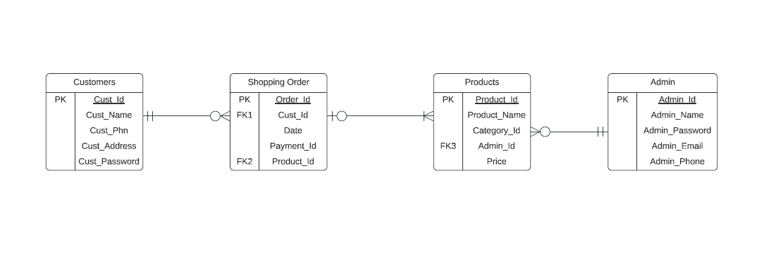
4.2. GUI
We are designing a prototype for GUI. So, that we’ll get a clear idea on front-end application part. We have used framer.com website to create this layout. This is the overall outflow of the application. We’ll add each web page screenshot individually to know it.
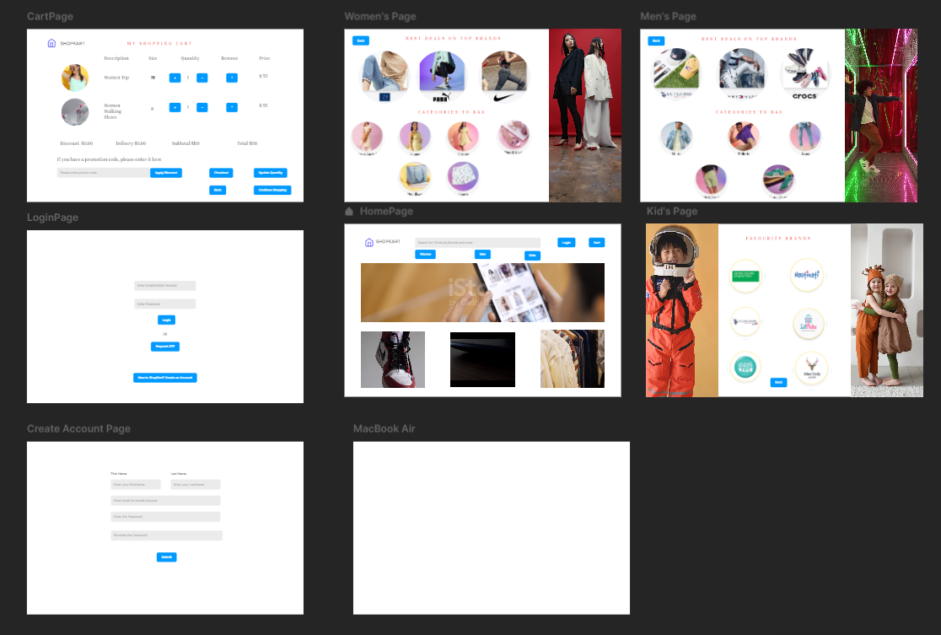

Home Page
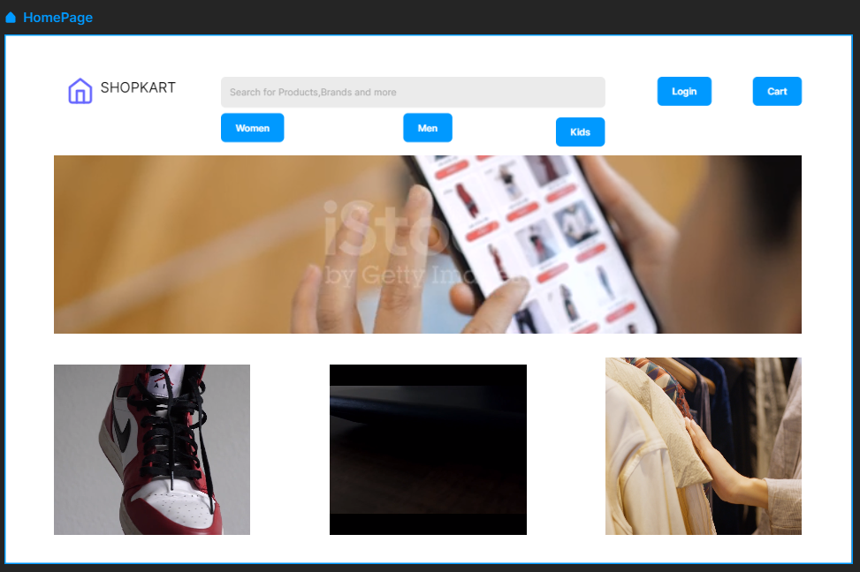

Login Page
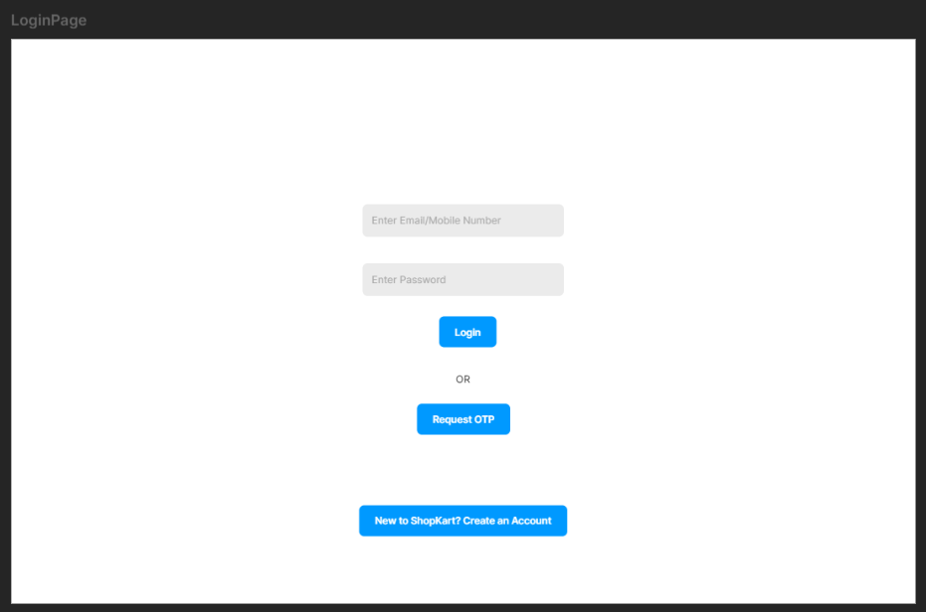
User Registration Page
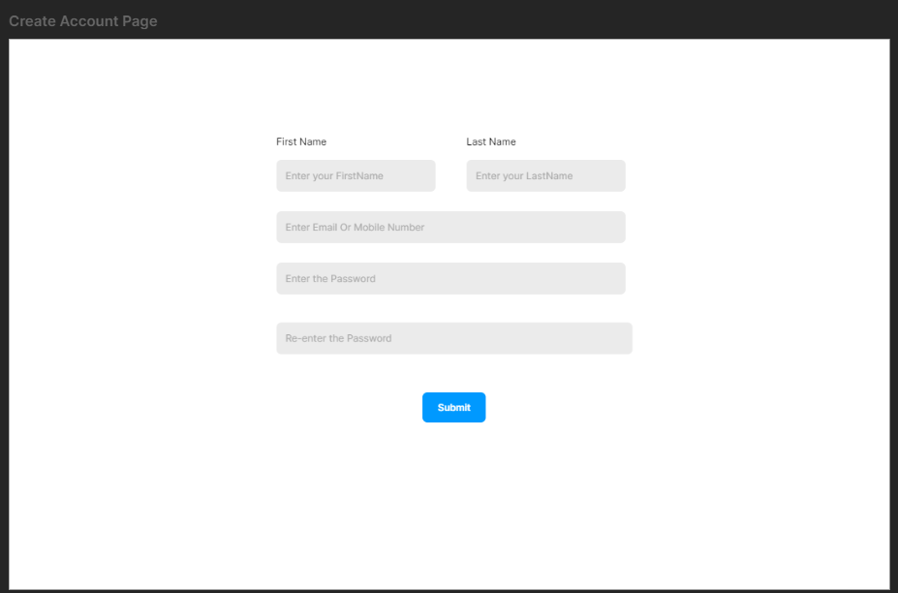
Categories
Men’s Page
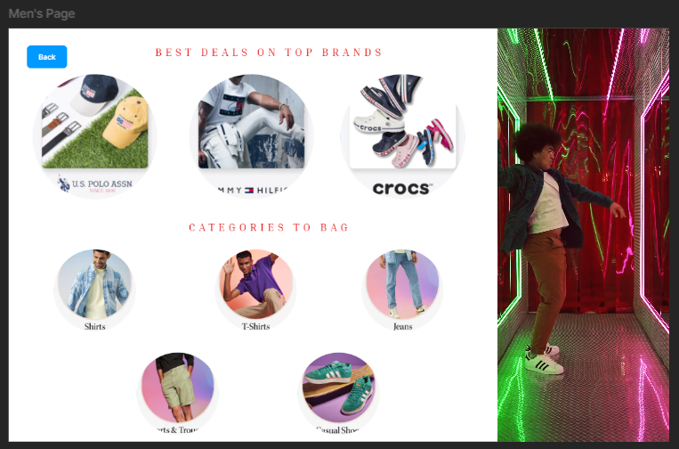
Women’s Page


Kid’s Page
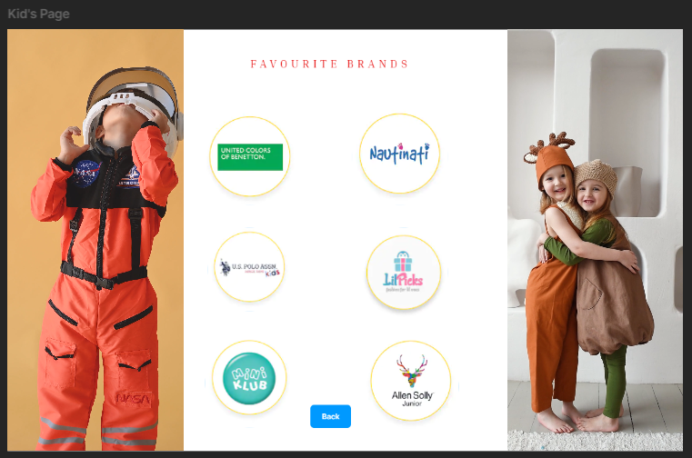

Cart Page
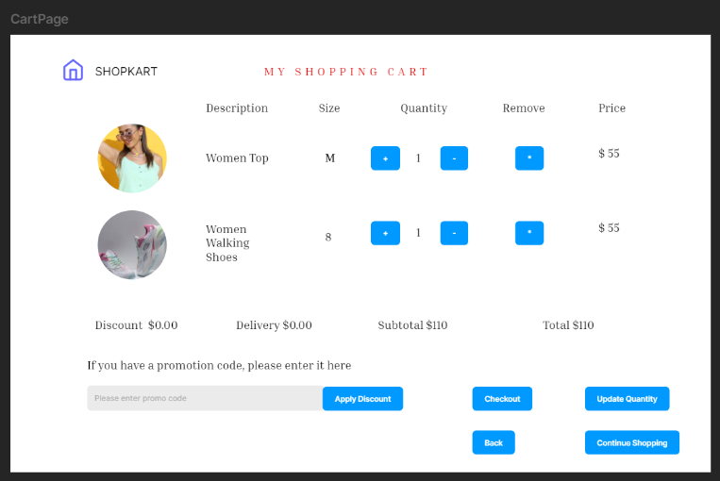

Checkout Page
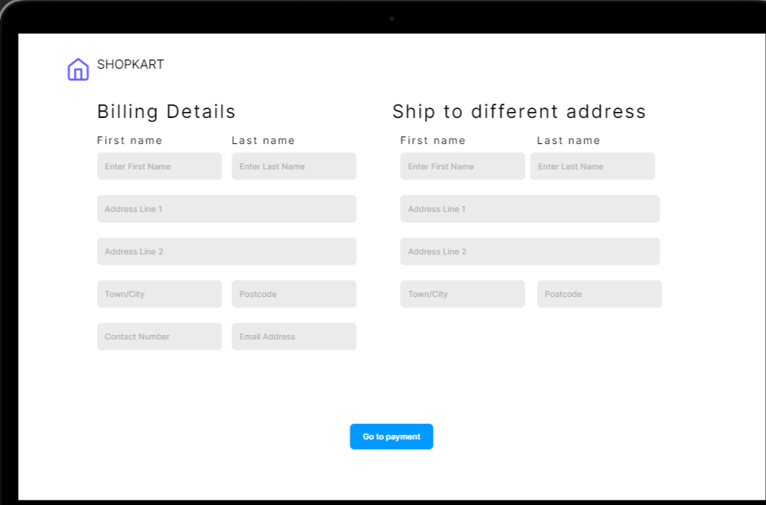

Payment Page
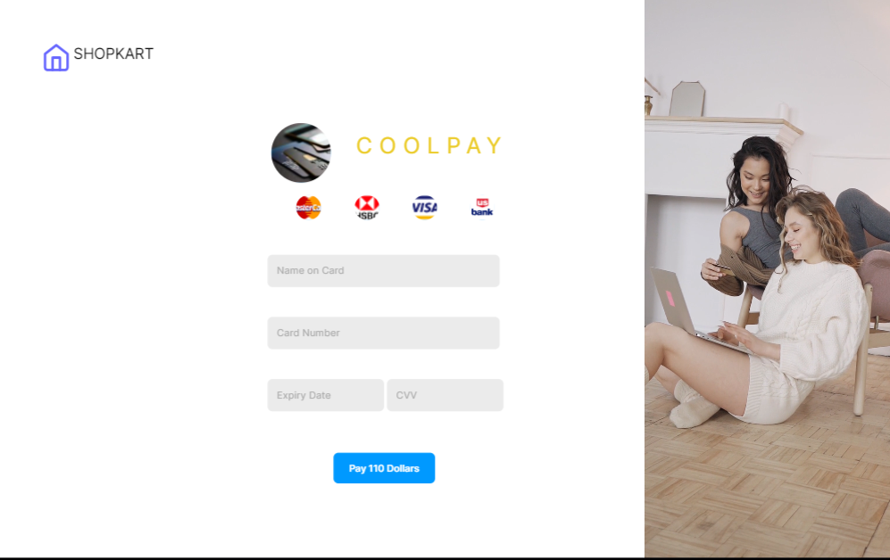

Order Confirmation Page
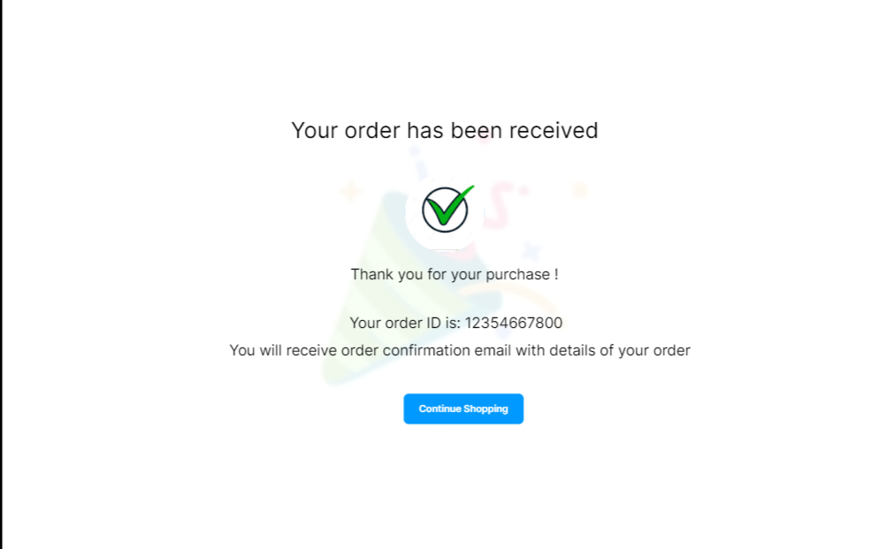

- Analysis Models
5.1. Data Flow Diagram
